**Question 1**

Renrendai:

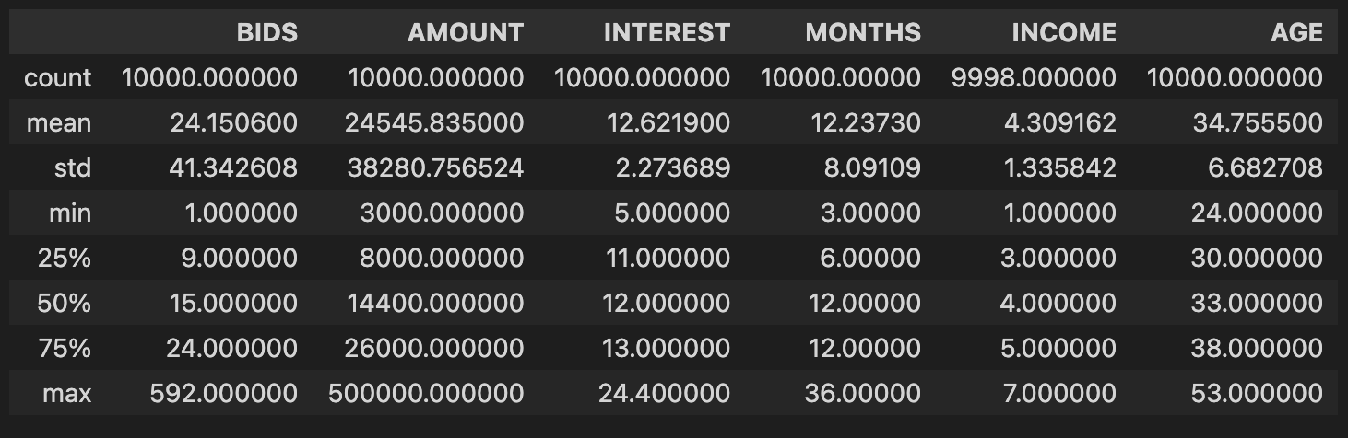

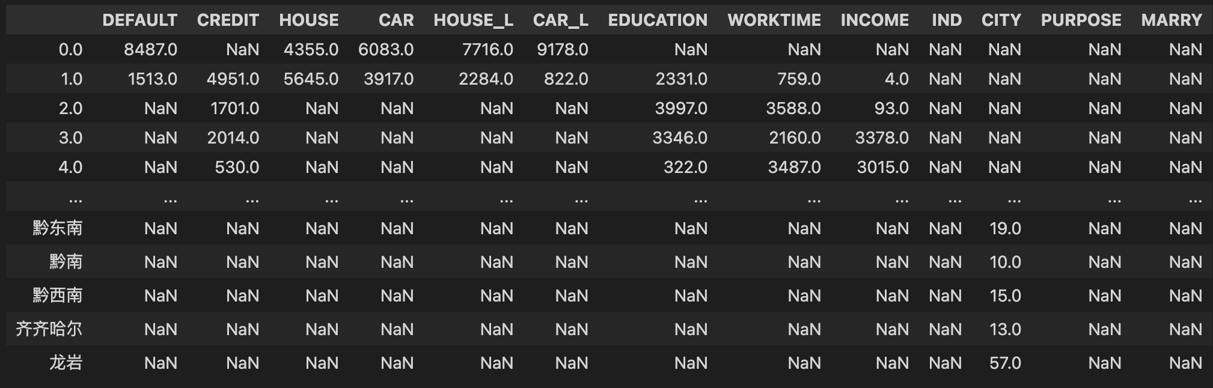

P2P:

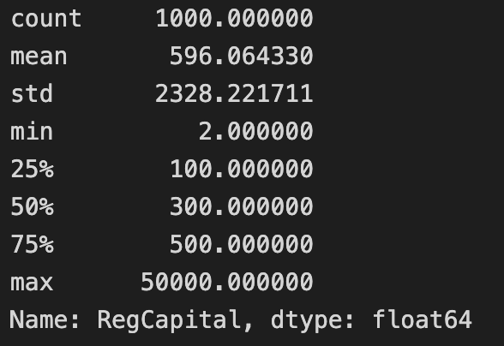

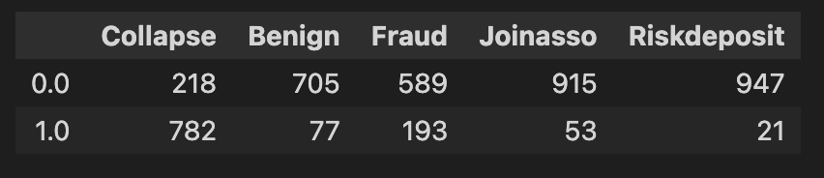

**Question 2**

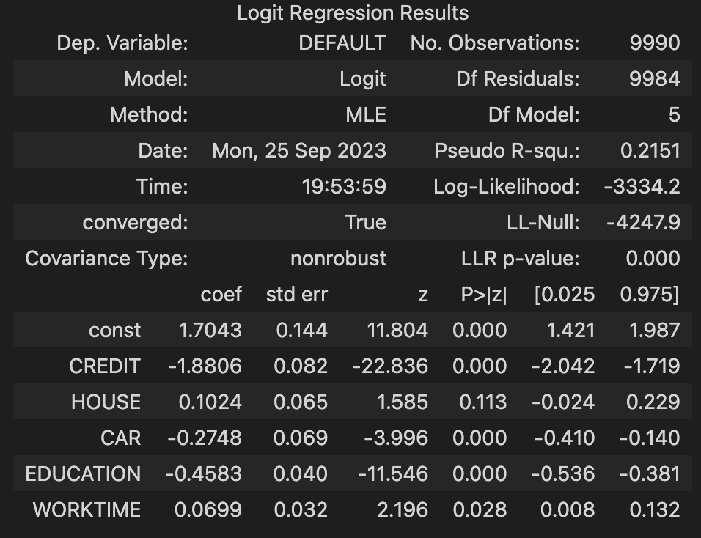

House and worktime are both positively related to the default likelihood, while car, education and credit are all negatively related to the default likelihood.

**Question 3**

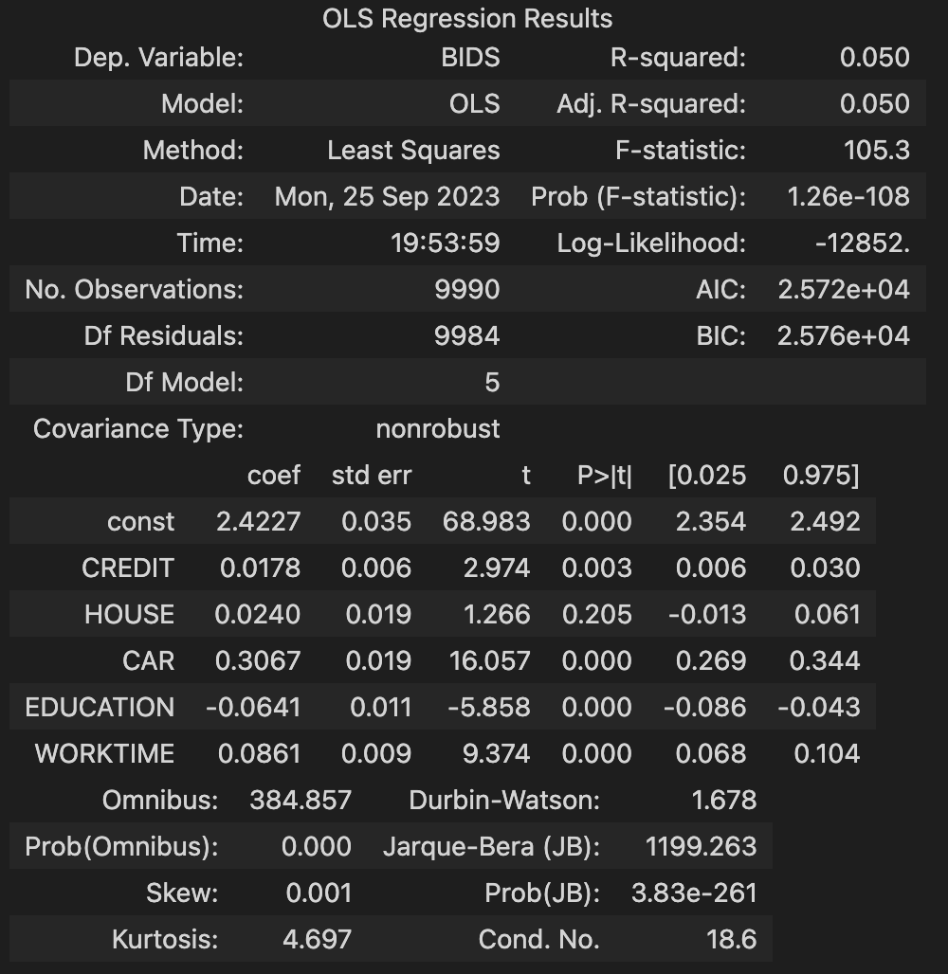

Credit, house, car and worktime are all positively related to the number of bids, while education is negatively related to the number of bids.

Question 4

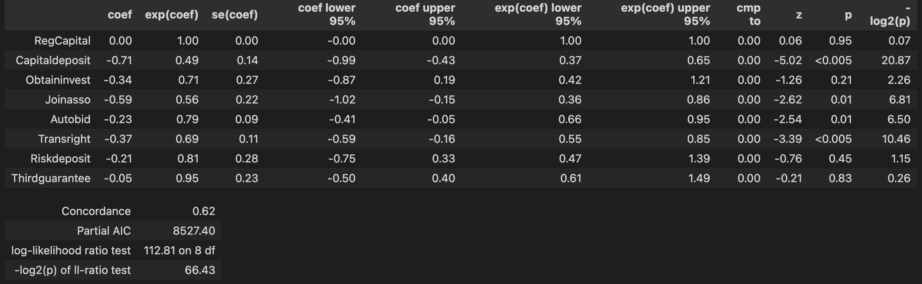

Increase in all the covariates, except RegCapital, leads to a decrease in risk.